**PRACTICAL NO 03**

**Implementing Aggregation**

a.Write a MongoDB query to use sum, avg, min and max expression.

Sum

Query :



Output :

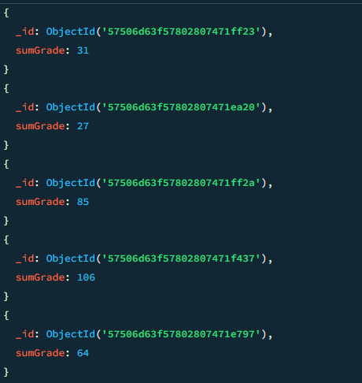

Avg

Query :



Output :

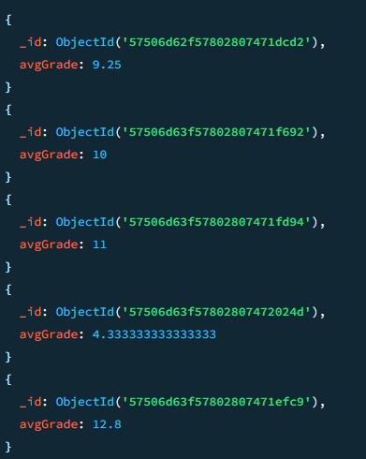

Min

Query :



Output :

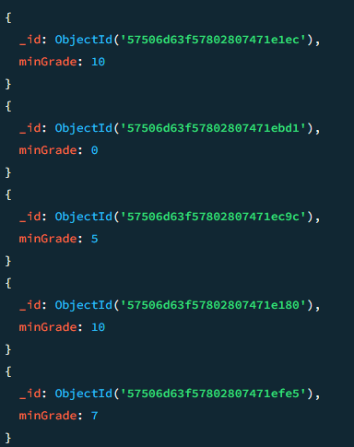

Max

Query :



Output :

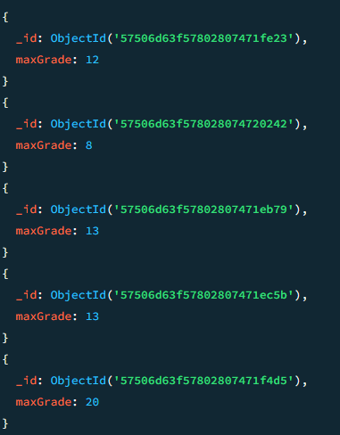

b.Write a MongoDB query to use push and addToSet expression.

Push

Query :



Output :

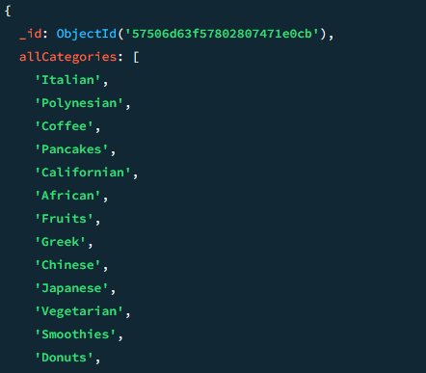

addToset

Query :



Output :

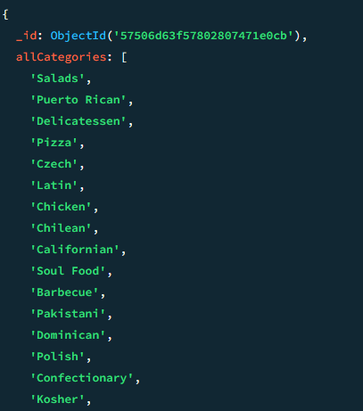

c.Write a MongoDB query to use first and last expression.

Query :



Output :

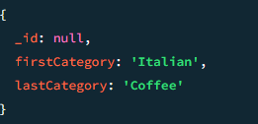s